Report for: | Planning Policy Advisory Panel
Date of Meeting: | 9th January 2023
Subject: | Draft Tall Buildings (‘Building Heights’) Supplementary Planning Document (SPD) –for consideration and recommendation to Cabinet for approval to consult
Key Decision: | No – advisory panel only
Responsible Officer: | Dipti Patel, Corporate Director Place  Viv Evans, Chief Planning Officer
Portfolio Holder: | Cllr Marilyn Ashton Deputy Leader of the Council, Portfolio Holder for Planning & Regeneration
Exempt: | No
Decision subject to Call-in: | No
Wards affected: | All Wards
Enclosures: | Appendix 1 – Draft Tall Buildings (‘Building Heights’) SPD

Section 1 – Summary and Recommendations
This report provides a progress update to the drafting of a draft Tall Buildings (‘Building Heights’) Supplementary Planning Document (“SPD”) (previously titled ‘Tall Buildings SPD’). The report sets out the approach to the drafting of the specific guidance and consultation that has been undertaken to assist in the drafting of the SPD. The Panel is invited to make comments on the initial draft SPD, which is attached as Appendix 1.

Recommendations:
The Panel is requested to:

- Note and comment on the change to the title of the draft SPD
- Note the contents of the report and the initial draft SPD (Appendix 1)
- Note the proposed timetable headlines contained paragraph 2.5
- Provide comments / feedback in relation to the information set out in this report and associated draft SPD (Appendix 1) (to inform any revisions prior to the draft being submitted to Cabinet for consideration and agreement to consult), and commend the draft SPD to Cabinet for approval to consult.
- Note the outline consultation arrangements should Cabinet agree to consult on the draft document.

Reason: (for recommendation)
To note the progress in drafting the SPD and to provide the opportunity for comment prior to the document being considered by Cabinet for consultation.

Section 2 – Report

1.0 Introduction

1.1 The Council has previously committed to prepare a Tall Buildings Supplementary Planning Document (SPD), which will directly respond to meeting a stated priority of the Council to provide guidance on tall buildings in suburbia to maintain the character of the area while allowing for growth.

1.2 This report provides an update to the Planning Policy Advisory Panel (PPAP) report and presentation on the 3rd October 2022, which set out the rationale behind progressing a tall building SPD, the policy framework, evidence base, and the proposed themes, objectives, and principles that the tall building SPD would be progressed on.

1.3 This report introduces the draft SPD based on the approach within paragraph 1.2 above, agreed at the PPAP meeting of the 3rd October 2022. The draft SPD sets out the reasoning for the SPD, evidence base, how and when to use the guidance, status of document and the guidance text and images.

1.4 Since the PPAP meeting on 3rd October 2022, it is proposed to title the SPD the ‘Tall Buildings (‘Building Heights’) Supplementary Planning Document’, for the reasons set out in Section 4 below.

1.5 This SPD does not apply within the Harrow & Wealdstone Opportunity Area. Opportunity Areas are designated through the London Plan, and are noted as areas where growth is directed to and are subject to significant change. It is recognised that the Harrow & Wealdstone Opportunity Area represents where growth has been strategically directed to over the local plan period, and as such has already undergone significant change including many tall building developments. This SPD will only apply to the suburban context of Harrow, which is outside of the designated Harrow & Wealdstone Opportunity Area, where the development plan does not envision such significant change and development opportunities.

2.0 Timetable

2.1 In bringing forward the SPD, the following sets out the key timetable actions required to be undertaken (Dates may be subject to change):

- Draft SPD for Planning Policy Advisory Panel: 9th January 2023
- Further refinement of draft SPD to reflect PPAP and ongoing internal review – January/February 2023
- Cabinet Approval to Consult on draft SPD: February 2023
- Consultation Period: February – March/April 2023
- Report back to Planning Policy Advisory Panel: April 2023
- Cabinet Approval to Adopt the SPD: May 2023

2.2 The draft SPD attached at Appendix 1 is the initial draft for consideration by the Panel; as a document it continues to evolve as the approach, terminology and content / images / diagrams are finalised. The document will be further reviewed for internal consistency with respect to terminology / diagrams and the like, as well as reducing any duplication.

3.0 Evidence Base

3.1 Following the agreement of the Planning Policy Advisory Panel.to progress with a supplementary planning document to provide guidance on tall buildings, based on the themes, objectives, and principles presented previously to PPAP (3rd October 2022), officers have progressed with the drafting of the SPD based on these and the relevant evidence base.

3.2 The drafting of the SPD follows relevant good practice guidance, and the Harrow Characterisation and Tall Building study, which was completed by Allies & Morrisons LLP in August 2021. The study was split into two main workstreams, with a complete character assessment of the entire borough, and secondly a specific tall building guidance element.

Characterisation Study

3.3 The Characterisation Study in assessing the borough wide context makes it clear that within suburban Harrow (outside of town centres, neighbourhood parades, growth areas), the prevailing character is largely between 2 to 3 storeys. Building heights are greater in town centres, namely in Harrow & Wealdstone town centre that has seen recent mixed use and residential schemes over 10 storeys. Non-residential buildings such as institutions, big box retails, and industrial only make a small proportion of the building typologies across the borough.

Tall Buildings

3.4 Specific to tall buildings, the study identifies a methodology which enabled a context-based definition of tall buildings, consistent with Historic England Advice Note 4 and London Plan Policy D9: Tall Buildings. As noted above, Policy D9 of the London Plan (2021) sets out that in defining tall buildings ‘the height of which will vary between and within different parts of London but should not be less than 6 storeys or 18 metres measured from ground to the floor level of the uppermost storey’. Notwithstanding this, the prevailing character of Harrow in terms of building heights is largely between 2 – 3 storeys, with building heights greater in town centres, namely in Harrow & Wealdstone town centres that has seen recent mixed use and residential schemes over 10 storeys.

3.5 Building on from the setting the prevailing pattern of development in any one location, the evidence base provides formulae (paragraph 5.4 below) which will assist in determining if a building that is less than 6 storeys / 18m in height) would be a contextually tall building within its location.

3.6 The above approach is considered to be consistent with the supporting text (to Policy D9 London Plan (2021)) within paragraph 3.9.3, which notes that ‘tall buildings are generally those that are substantially taller than their surroundings and cause a significant change to the skyline’. Buildings across much of Harrow are 2 to 3 storeys in height, and within that context a building twice the height would be substantially taller and make a significant change to the skyline.

4.0 Informal Consultation

4.1 Throughout the drafting of the SPD, officers have engaged informally with key external and internal stakeholders, to ensure that any key points would be able to be addressed at an early stage. The consultation undertaken to date has been informal, with formal, wider consultation undertaken once the drafting of the SPD has progressed to a point where it has been considered by Cabinet and agreed for formal consultation.

External Consultation

Greater London Authority (London Plan Team)

4.2 The Greater London Authority (GLA) constitute a statutory consultee for new planning documents being produced by Local Planning Authorities. Harrow officers engaged informally with GLA officers on the 10th October 2022 to set out the proposed approach to progressing the SPD, as advised at the Planning Policy Advisory Panel on 3rd October 2022. GLA officers were able to provide feedback in relation to, among other things, the compliance of the proposed approach to the SPD with the London Plan (2021) and associated London Plan Guidance (LPG).

4.3 GLA officers were generally supportive of the approach proposed for the SPD, however their overriding concern was in relation to the potential conflict between buildings that may be considered perceptively tall within Harrow, and what would constitute a tall building as defined in Policy D9 (Tall buildings) of the London Plan (2021). The SPD intends to provide guidance for both tall and contextually tall buildings.

4.4 GLA officers recommended reviewing the proposed title of the SPD to assist in mitigating any confusion and potential conflict between the SPD and Policy D9 of the London Plan (2021).

4.5 In response to the potential conflict with the title of the SPD, it is proposed to rebrand the title to ‘Harrow Tall Buildings (‘Building Heights’) SPD’. This would seek to address the GLA’s concerns whilst retaining the words ‘tall buildings’ to reflect what the public recognise the document to be about. An alternative name could also be Harrow Building Heights (Tall and Contextually Tall Buildings) SPD. This alternative name has the benefit of clearly articulating that the draft SPD also covers ‘contextually tall’ buildings (i.e. those that are below the London Plan 6 storey / 18 meter definition but are tall in their context i.e. two storey Metroland).

4.6 With regard to the potential conflict between applying the SPD and the requirements as set out in Policy D9 of the London Plan (2021), officers have proposed a traffic light system with explanatory text to guide applicants how and when to use the SPD depending on the specific development proposal (i.e. whether the proposal represents a ‘tall building’ has specifically defined by the London Plan, or a ‘contextually tall’ building as identified by the building heights within the locality of the development, applying the formula in section 5 below.

4.7 Officers consider that the proposed changes should adequately address the concerns raised by the GLA, and maintain the outcomes originally sought by the SPD as the approach remains as set out in the report to the PPAP meeting on 3rd October 2022.

Metropolitan Police (MET) (Secure by Design)

4.8 The MET (Secure by Design) constitute a statutory consultee who will be consulted with in relation to the draft document. Informal consultation was undertaken to allow the drafting process for the SPD to be informed from an early stage of the Secure by Design issues that taller buildings / proposals where higher density is proposed present, whereby ensuring guidance can look to address such issues early in the drafting.

4.9 The feedback points raised from the MET are noted as the following;

- Separate staircase provided for fire escape only
- Cycle storage facilities should be behind two lockable doors
- Storage areas should not hold more than 70 cycles
- Bin Storage
- Postal Strategy
- Ground floor use
- Podium access
- Roof access

4.10 The draft SPD has specific guidance on Secure by Design (SbD), which principally advises applicants that schemes must be designed with the SbD principles being addressed throughout the design progression of a scheme. However, a number of the points raised are relevant to several objectives / principles within the draft guidance, and therefore officers have included these where appropriate within the document.

Harrow Design Review Panel (DRP)

4.11 Harrow’s Design Review Panel is a panel of suitably qualified / experienced architects / development professionals that provide independent reviews of developments and emerging policy documents. The draft SPD was presented to a panel comprised of two architect / urban design experts with experience of tall buildings developments, SPD formulation and are also very familiar with the London Borough of Harrow and its character.

4.12 The DRP reviewed the draft SPD and provided several recommendations to officers which would assist in improving the quality and useability of the SPD, which will assist in its use in making decision / appeals. The following provides a summary of the points raised:

- The relationship between the draft SPD and the draft Small Sites Design Code SPD should be clarified. The draft Tall Buildings (‘Building Heights’) SPD should only provide guidance specific to buildings of height and not general design guidance as these should be set out in the borough wide design principles within the draft Small Sites Design Code SPD. Additional guidance may need to be included into the draft Small Sites Design Code SPD.

- Setting out a Council Vision for tall buildings, height and sensitive densification across the borough. It should outline the general attitude and approach to height, and set out the benefits and disbenefits of height are for Harrow. This could also include a vision for how families can live comfortably and well in taller buildings.

- The SPD should make best use of case studies and precedents, using those from across London as opposed to simply within the borough, so as to better illustrate guidance points and set high aspirations for future development.

- A review of the document to ensure that terminology is consistent, and terms that are used are defensible when / if scrutinised by applicants.

- Officers are advised to simplify design guidance theme headings and provide a clear definition for what these mean in the explanatory text.

- Design guidance text should be condensed and made simpler. Certain guidance points are overly long and ill-defined and should be revised to provide succinct points which offer a clear steer to design teams using the SPD

- The graphic design of the draft SPD feels over-designed in places and certain sections are difficult to read due to the large amount of information. It is advised to bring a graphic designer on board to provide a graphic template for the document.

- More guidance / greater emphasis on family living, in terms of appropriate locations for family sized homes, additional guidance on play space.

- The feedback provided a number of comments in relation to amendments to specific guidance around use of terminology.

4.13 Officers will present the final draft SPD to the DRP prior to its formal consultation.

Internal consultation

4.14 Internal Harrow departments have been consulted in the process of drafting the guidance and images for the SPD, by reason of potential densities of such schemes having potential impacts / servicing requirements on several services provided by the Council. Specifically, the following were internal departments were consulted;

- Development Management (x2)
- Highways Authority
- Waste Authority
- Drainage Authority
- Environmental Health
- Landscape / Biodiversity

4.15 The above service providers / departments have been all engaged in informal discussions throughout the drafting of the SPD, providing useful feedback in relation to the issues that their services face when dealing with tall buildings. The guidance has been drafted to take into consideration where appropriate comments received from the departments listed above. Officers will continue to consult these departments / service as the draft SPD develops, including any potential changes arising from the formal consultation process (if agreed to by Cabinet).

Formal Consultation

4.16 The paragraphs above outline the informal internal and external consultation that has informed the development of the draft SPD. The presentation of the draft SPD to the Panel (this report) and comments received will also inform the drafting of the document prior to it being presented to Cabinet for consideration and approval to formally consult on the draft SPD.

4.17 In undertaking formal consultation on the draft SPD, this will need to follow the statutory process for the preparation and adoption of SPDs, including consultation in accordance with the Harrow Statement of Community Involvement (SCI).

4.18 Details of the consultation are being developed and will be outlined in detail in the report to Cabinet, but in general terms is likely to involve:

- SPD published on Harrow online engagement portal, which will include a consultation questionnaire.
- Harrow Council website – Local Plan page
- Harrow Press notice
- Harrow Council social media
- Email to be sent to MyHarrow accounts
- Emails sent to consultees on the Local Plan database, who have indicated they are interested in Planning Policy consultations;
- Engagement sessions (potentially two), online and / or in-person (to be confirmed).

4.19 The consultation will be open for a minimum period of six weeks and will commence as soon as practicable following the approval by Cabinet. The outcome of the consultation, and any resulting amendments to the SPD, will be reported back to the Panel and Cabinet as part of the adoption process. In accordance with the requirements of the Town and Country Planning (Local Planning) (England) Regulations 2012, the Council must publish a consultation statement explaining how any issues raised in representations have been addressed in the SPD.

5.0 Draft Tall Buildings (‘Building Heights’) Supplementary Planning Document

5.1 Supplementary Planning Documents build upon and provide more detailed advice or guidance on policies in an adopted local plan. As they do not form part of the development plan, they cannot introduce new planning policies into the development plan. They are however a material consideration in decision-making. The SPD will provide further guidance principally to Policy DM1 (Achieving a High Standard of Delivery) of the Harrow Development Management Policies Local Plan (2013). It will also supplement any forthcoming tall building policy that will be brought forward through the local plan review.

5.2 The draft SPD has been progressed based on the relevant evidence base, and the themes / objectives / principles previously noted and agreed at the 3rd October Planning Policy Advisory Panel meeting. Building on this, officers have informally consulted with relevant external and internal stakeholders to assist in ensuring that as drafted the SPD would address the technical / operational requirements of those stakeholders.

5.3 The draft SPD is proposed to be set out in the following format, which will give effect to paragraphs 5.4 – 5.14 set out in this report. The full contents are set out on Page 3 of the draft SPD.

- Introduction
- Understanding Harrow’s existing character
- Deigning Tall and Contextually Tall Buildings
- Design principles and objectives
- Application process and requirements.

5.4 The draft SPD proposes to provide guidance to demonstrate how height should be considered across the suburban areas of Harrow. The draft SPD sets out how a context analysis will need to be undertaken to support applications, to demonstrate what the prevailing context is in any specific suburban location, specifically in relation to height. The SPD will only be relevant to developments within suburban Harrow, and not for developments that are proposed within the Harrow & Wealdstone Opportunity Area. The draft SPD provides images to demonstrate how this context analysis would be undertaken and provides guidance on the spatial element to this (i.e., how far from the application site should form part of the analysis).

5.5 Once an established context has been determined for an application site, applicants are then able to utilise the formula below to determine if the proposed development would be contextually tall within any specific location.

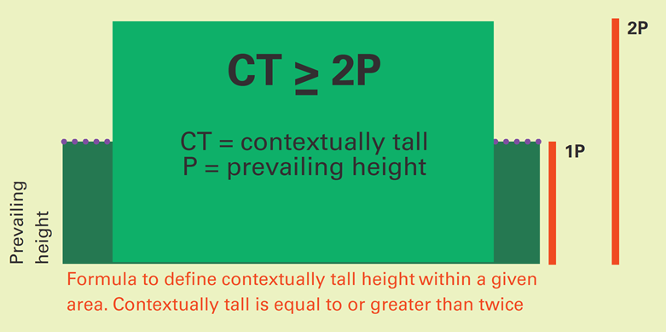

5.6 Buildings that exceed the tall building threshold as set out in Policy D9 (Tall buildings) of the London Plan (2021) (6 storeys / 18m) will not need to apply the formula (as they will by default be defined as ‘tall buildings’ as per the London Plan). Proposals within the Harrow & Wealdstone Opportunity Area do not need to apply the formula or follow the guidance in the SPD, rather shall follow the policies within the Harrow & Wealdstone Area Action Plan (2013) and development plan policies.

5.7 Proposals determined to be tall (London Plan definition) and/or contextually tall, as determined through the context analysis and application of the formulae, will need to then follow the guidance within the draft SPD. Buildings that exceed the London Plan definition must be considered against Policy D9 (Tall buildings) of the London Plan (2021) also.

5.8 It is acknowledged that tall buildings as defined by Policy D9 (Tall buildings), which exceed 6 storeys / 18m in height, have more potential to cause a greater number and greater degree of harm. For this reason, a greater level of design scrutiny should be applied to taller buildings, and conversely those that are not as high, would not be subject to the same level of scrutiny / guidance. However, this does not mean that a high standard of design should not be achieved by all developments.

5.9 It is proposed to address this issue by introducing a traffic light system, that will provide specific guidance for either or both tall buildings (as per London Plan 2021, or as contextually tall). The traffic light system will direct applicants which of the design guidance is relevant to their specific scheme, which will be determined by its height. This process is set out in the diagram below (extracted from the draft SPD).

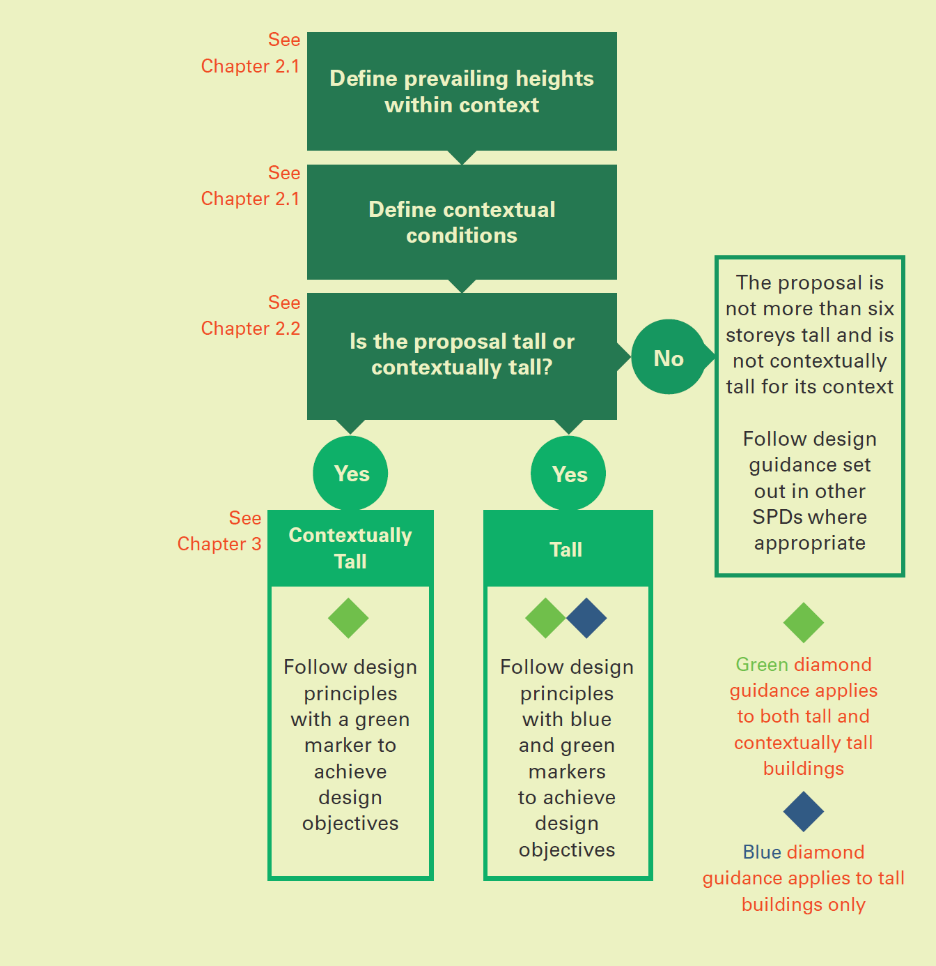

5.10 Once it is determined which guidance a scheme is required to be considered against, applicants will be expected to demonstrate in supporting information an assessment of their scheme against the relevant objectives, principles, and associated guidance. The guidance is contained with Chapter 3 of the draft SPD, which is attached as Appendix 1.

5.11 Chapter 3 follows the following three overarching themes:

(a) Addressing Place
(b) Delivering Quality
(c) Creating Good Growth

5.12 The Addressing Place theme has the objectives (a) responding the character of suburban Metroland, (b) protect built and landscape heritage, and (c) locate height appropriately; these link building heights to location and context. Of particularly note in the context in which the document has been prepared is the guidance that ‘Given the strong character across suburban Metroland, specifically in relation to heights being between 2-3 storeys, proposals that meet the London Plan (2021) tall building definition (6 storeys or 18 metres measured from ground to the floor level of the uppermost storey), would not be supported’ (see Design Principle A2).

5.13 The themes of Delivering Quality and Creating Good Growth provide guidance in relation to design and outcomes (‘good growth’).

Conclusion

5.14 The draft SPD seeks to provide a context-based approach to delivering height across the suburbs of the borough, and to ensure that developments are of a high design quality specifically where they are taller than the surrounding buildings and pattern of development.

6.0 Implications of the Recommendations

Considerations

7.0 Resourcing

7.1 The project is being resourced internally by the Planning Policy Team, from the existing revenue budget. Significant input has been required from the Council’s Principal Urban Design Officer (located within Development Management).

7.2 Were it decided to seek additional external drafting input (i.e. external graphic design or procurement of additional internal design software) as suggested by the Design Review Panel, or additional Counsel advice sought, this would require additional budget to be identified.
8.0 Ward Councillors’ comments

8.1 Ward Councillor input will be sought during any formal consultation on the draft document.

9.0 Performance Issues

9.1 None: Report is for information purposes and comment only. Performance issues will be considered as part of any future Cabinet Report.

10.0 Environmental Implications

10.1 None: Report is for information purposes and comment only. Environmental implications will be considered as part of any future Cabinet Report.

11.0 Data Protection Implications

11.1 None: The report is prepared for information purposes and comment only for the Planning Policy Advisory Panel, which is noted as being a publicly accessible forum

12.0 Procurement Implications

12.1 There are no procurement implications arising from this report as it is limited to seeking comment and feedback on a draft SPD and to comment the document to Cabinet for approval to consult.

13.0 Risk Management Implications

Risks included on corporate or directorate risk register? No

Separate risk register in place? No

The relevant risks contained in the register are attached/summarised below. N/A

The following key risks should be considered when agreeing the recommendations in this report:

Risk Description | Mitigations | RAG Status
Non-compliance with regulatory requirements for the preparation of any guidance (i.e. scope of guidance, process.) | - Scope of guidance will have regard to previous Counsel advice regarding this  - Consideration to be given to obtaining further Counsel advice on the draft document to confirm statutory compliance and to advise on the robustness and defensibility to draft  - Process (including formal consultation) managed to ensure it complies with regulatory requirements | Green
Non-(general) conformity / consistency with Harrow development plan (i.e. London Plan, Harrow Local Plan) | - Drafting to be undertaken in context of existing development plan.  - Opportunities to expedite (‘twin-track’) the development of relevant policy as part of Local Plan review to be considered in an effort to reduce any potential conflict with future Local Plan policy.  - Informal consultation has been undertaken with the Greater London Authority (GLA) to ensure compliance with the London Plan (2021) | Green
Broader Planning Policy / Urban Design work programs impacted upon should additional resources to undertake the work outlined in this report is not forthcoming | - Work programmes to be reprofiled to reflect available resources. This does not fully mitigate the risk as reputational damage may arise if other work (for example, that relating to planning applications) is delayed. | Green

14.0 Legal Implications

14.1 Section 38(6) of the Planning and Compulsory Purchase Act (2004) states that, if regard is to be had to the development plan for the purpose of any determination to be made under the planning Acts, the determination must be made in accordance with the plan unless material considerations indicate otherwise.

14.2 The Town and Country Planning (Local Planning) (England) Regulations 2012 provide guidance on the preparation and adoption of supplementary planning documents.

14.3 Although the proposed draft SPD is not a development plan document it will, on adoption, be a material consideration in the determination of tall building development proposals within the London Borough of Harrow.

14.4 The Council is required by law to consult on the draft SPD and to consider all consultation responses received before adopting the SPD. As soon as reasonably practicable after adopting an SPD, the Council must (i) make available the SPD and an adoption statement and (ii) send a copy of the adoption statement to any person who asked to be notified of the adoption of the SPD.

14.5 By definition, supplementary planning documents cannot introduce new policies nor modify adopted polices and do not form a part of the development plan. Rather, their role is to supplement a ‘parent’ policy in a development plan document. The SPD supplements Policy DM1 (Achieving a High Standard of Development of the Harrow Development Management Policies Local Plan (2013).

15.0 Financial Implications

15.1 The cost of preparing and implementing the guidance on tall buildings will be met from Planning Policy Team and Development Management (Urban Design) resources. Any additional external costs (such as those identified in paragraph 7.2 above) would need to be met from within existing revenue budgets.

16.0 Equalities implications / Public Sector Equality Duty

16.1 The Equality Act 2010 outlines the provisions of the Public Sector Equalities Duty which requires Public Bodies to have due regard to the need to:

a) Eliminate discrimination, harassment and victimisation and other contact prohibited by the Equality Act 2010.

b) Advance equality of opportunity between persons who share a relevant protected characteristic and persons who do not share it.

c) Foster good relations between persons who share a relevant protected characteristic and persons who do not share it.

The broad purpose of this duty is to integrate considerations of equality into day to day business and keep them under review in decision making, the design policies and the delivery of services.

16.2 The relevant protected characteristics are age, race, disability, gender reassignment, pregnancy and maternity, religion or belief, sex and sexual orientation.

16.3 The SPD aims, among others, for an inclusive and safe development for all and therefore advances equality of opportunity for all and is not considered to adversely impact on persons within the protected characteristic.

16.4 In addition, the proposed SPD the subject of this report will provide guidance and supplement adopted policies within the Harrow Core Strategy and Development Management Policies in the Local Plan. A full equalities impact assessment was carried out at each formal stage in the preparation of the Core Strategy and Development Management Policies Local Plan..

17.0 Council Priorities

17.1 Putting residents first.

17.2 The progression of a Tall Buildings (‘Building Heights’) Supplementary Planning Document was a manifesto commitment by the new administration. This report sets out the drafting of a Tall Buildings (‘Building Heights’) SPD, which would reflect the priorities of the Council to put residents first. Notwithstanding the change to the title of the document, it reflects the commitment made by Cabinet at its May 2022 meeting.

Section 3 - Statutory Officer Clearance

Statutory Officer: Jessie Man
Signed on behalf of the Chief Financial Officer

Date: 22 December 2022 – by email
Statutory Officer: Mrinalini Rajaratnam
Signed on behalf of the Monitoring Officer

Date: 22 December 2022 – by email
Chief Officer: Viv Evans
Signed off by the Chief Planning Officer
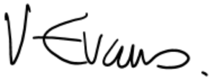

Date: 21 December 2022

Mandatory Checks

Ward Councillors notified: No, as it impacts on all Wards. Cabinet consideration will be a Key Decision.

EqIA carried out: No: refer to paragraph 16 above

EqIA cleared by: N/A

Section 4 - Contact Details and Background Papers
Contact: Callum Sayers, Principal Planning Policy Officer, 077 3159 1724, callum.sayers@harrow.gov.uk
Background Papers:
- National Planning Policy Framework (2021)
- London Plan (2021)
- Harrow Local Plan

Appendix 1: Draft Tall Buildings (‘Building Heights’) Supplementary Planning Document

See Cabinet meeting 24 May 2022, item 5 (https://moderngov.harrow.gov.uk/documents/s176909/Cabinet%20Report%20-%20May%202022%20-%20Tall%20Buildings%20and%20Conversions%20-%20FINAL%20V2%20-%20220517.pdf)

